­./

GENESIS - Learning Outcome & Mini-project Summary Report



|  |  |  |  |  |  |
| --- | --- | --- | --- | --- | --- |
| **Ver. Rel. No.** | **Release Date** | **Prepared. By** | **Reviewed By** | **To be Approved** | **Remarks/Revision Details** |
|  |  | Asha N |  |  |  |
|  |  |  |  |  |  |
|  |  |  |  |  |  |
|  |  |  |  |  |  |
|  |  |  |  |  |  |

**Details**

Contents

Contents 3

Miniproject -1 [Team/Individual] 4

Module/s 4

Topic and Subtopics 4

Objectives & Requirements 4

Design 4

Test Plan 4

Implementation Summary 4

Video Summary 4

Git Link 4

Git Dashboard 4

Summary 4

Individual Contribution & Highlights 5

Summary 5

Challenges faced and how were they overcome 5

Future Scope (If applicable) 5

Miniproject -2 [Team/Individual] 6

Module/s 6

Topic and Subtopics 6

Objectives & Requirements 6

Design 6

Test Plan 6

Implementation Summary 6

Git Link 6

Git Dashboard 6

Summary 6

Individual Contribution & Highlights 6

Summary 6

Challenges faced and how were they overcome 6

# Miniproject -1 [Team/Individual]

## Module/s

“Modules linked to the miniproject Ex – Linux, SDLC and C++ or SDLC and HTML etc”

### Topic and Subtopics

“Briefly list the core topics and subtopics being implemented and how”

## Objectives & Requirements

“High level and low level in the template ”

## Design

“System Level and subsystem level UMLs – Structural and Behavioral”

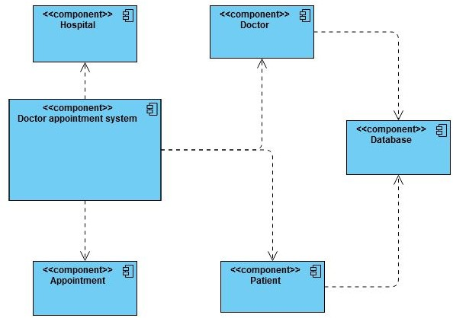

## Test Plan

“Integration level and unit level in the template”

**2.1 High level requirements:**

|  |  |
| --- | --- |
| **ID** | **Description** |
| HL_01 | Analysis of patient details. |
| HL_02 | Comparison of different diseases |
| HL_03 | Highest and lowest aged patients. |
| HL_04 | Adding new patient details |

**2.2 Low level requirements:**

Low level requirements:

|  |  |
| --- | --- |
| ID | Description |
| LL_01 | Reading data from csv file. |
| LL_02 | Saving all data on list using STL concepts |
| LL_03 | Implementation of CI/CD. |

## Implementation Summary

“Section focused toward’ s implementation aspects. Here it is only core summary while all the details are in the Git Repo

Note: The GitHub private repo should be documented (Readme.md files at each folder level)

Ensure code quality and clean code and description practices

Mandatory: To add the GitHub user - **stepin654321** as a contributor to the repo”

### Video Summary

“Please upload a short video on the repo for the walkthrough of the project (Team/Individual) less than 7min and less than 30MB File Size. Start is the Standard opening slide with title of miniproject + Team members followed by the walkthrough ”

### Git Link

“Link to the repo”

GitHub repo link : <https://github.com/99002646/MiniProject_Cpp>

### Git Dashboard

“Screenshot of the GitHub Repo page with all the badges and summary”

### Summary

“Brief summary on the overall implementation”

#### Git inspector summary

“In linux install gitinspector and Run the command –

gitinspector -H -l -m -T -w -r --grading --format=html > gitinsp.html

and upload the same to your repo and paste the snapshot in the report”

#### Build

“Brief on outcome of the build and setup done”

#### Code quality and Issues or Bug Tracking

“Brief on code quality, errors and warnings flagged (issues created) and fixed ”

#### Unit Testing

“Unit Testing setup alignment with test plans and summary of outcome”

## Individual Contribution & Highlights

“Brief on Contributions by you for Team”

### Summary

“Key Highlights not covered till now, Softskills and technical side”

### Challenges faced and how were they overcome

“Brief and crisp”

### Future Scope (If applicable)

### 

# Miniproject -2 [Team/Individual]

## Module/s

### Topic and Subtopics

## Objectives & Requirements

## Design

## Test Plan

## Implementation Summary

### Git Link

### Git Dashboard

### Summary

#### Git inspector summary

#### Build

#### Code quality

#### Unit Testing

#### Issues

## Individual Contribution & Highlights

### Summary

### Challenges faced and how were they overcome